**Prepayment-Mortgage-Trading-Analysis-and-Prediction**

**Initial Task: Data Preprocessing**

1. **Data Cleaning:** Handle missing values, remove duplicates, and ensure correct data types.
2. **Data Encoding:** Convert categorical variables into numerical formats.
3. **Data Labeling:** Properly label the dataset for analysis.

**Data Cleaning Done Using Python:** **C:\Users\omkar\Downloads\Python Technolab.ipynb**

**Dashboard Building**

1. **Objective:** Visualize delinquency metrics using Tableau.
2. **KPIs:**
   * **Average Months Delinquent** and **Percentage of Loans Ever Delinquent** are calculated and displayed Using Tableau.
   * Steps Are as follow:
   * **Load Your Data**
   * **Create a Calculated Field**

* **For Average Months Delinquent** -AVG([Months Delinquent])
* **For "Percentage Ever Delinquent"-** SUM([Ever Delinquent]) / COUNT([Loan ID])
  + **Display as KPI**
  + **Format the KPI**
  + **Add to Dashboard**

1. **Visualizations:**
   * **Histogram** showing distribution of months delinquent.
   * **Line Chart** visualizing the trend of delinquency rates over time.
   * **Bar/Pie Chart** depicting percentage of loans ever delinquent by credit range.

**Dashboard Design Choices & Assumptions**

**Design Choices:**

* **Card Visualizations** were used for key performance indicators (KPIs) like average months delinquent and the percentage of loans ever delinquent to provide clear, at-a-glance insights into critical metrics.
* **Histogram** was chosen to visualize the distribution of delinquency across different time periods, offering a detailed view of how delinquencies are spread among loans.
* **Line Chart** was selected to illustrate the trend of delinquency rates over time, making it easy to observe patterns and changes in loan performance.
* **Bar/Pie Chart** was used to compare delinquency rates across different credit ranges, highlighting which segments of the loan portfolio are more prone to delinquency.

**Assumptions:**

* It was assumed that all loans with a "Month Delinquent" value greater than zero have been delinquent at some point, making them relevant for the delinquency calculations.
* Data quality was presumed to be consistent across the dataset after cleaning, ensuring reliable results in the visualizations.
* The time-based analysis assumed that the provided date or month column accurately reflected the time when delinquency events occurred.
* **Created Dashboard in Tableau:**

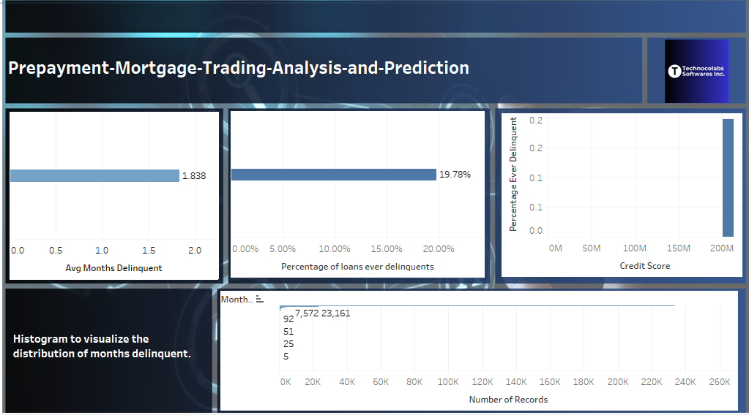

This report outlines the key steps, design choices, and assumptions made in the creation of a dashboard to analyze mortgage delinquency, providing a foundation for informed trading decisions.